**Ideation Phase**

**Empathize & Discover**

|  |  |
| --- | --- |
| Date | 20 OCTOBER 2022 |
| Team ID | PNT2022TMID03634 |
| Project Name | Project - Smart Waste Management For Metropolitan Cities |
| Maximum Marks | 4 Marks |

**Empathy Map Canvas:**

An empathy map is a straightforward, simple-to-understand picture that summarises information about a user's actions and views.

It is a helpful tool that enables teams to comprehend their users more fully.It's important to comprehend both the actual issue and the individual who is experiencing it in order to develop a workable solution.

The exercise of creating the map helps participants consider things from the user’s perspective along with his or her goals and challenges.

**Example:**

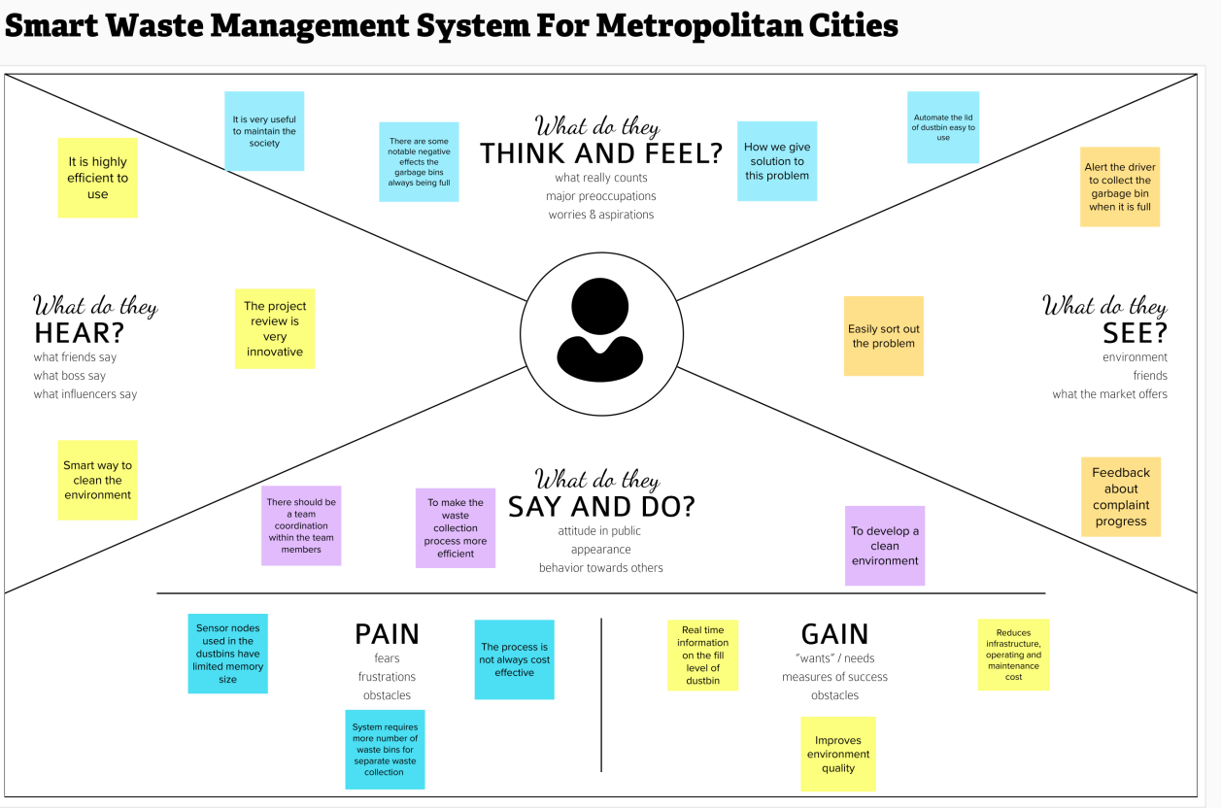

**Reference**: <https://www.mural.co/templates/empathy-map-canvas>